# Introduction to Computer Science and Programming 1

# CSCI120

### Chapter1

### Sample Practices with Answers

**Note:** This document has been designed and developed as part of an initiative for creating an OER (Open Education Resource) package for the course CSCI 120 at Columbia College.

Please contact [Alireza.davoodi@gmail.com](mailto:Alireza.davoodi@gmail.com) for any comment, modification, and questions.

**Terms of use:** Please feel free to customize this document as needed

Last Modified: July 2022

**Problem1**

* Design an algorithm and a flowchart for an application which receive a number from the input and print a shape like this: (if the input is 6)

******

*****

****

***

**

*

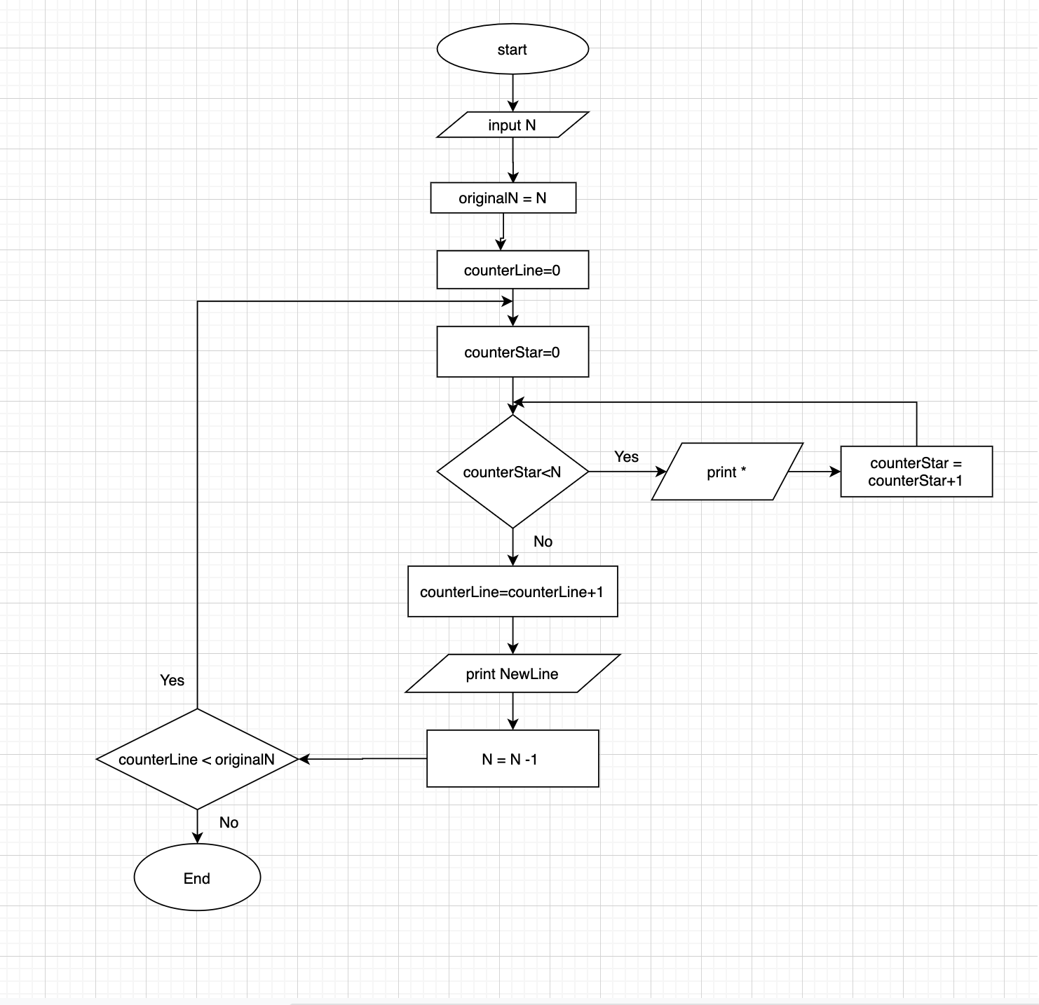

|  |  |  |  |  |
| --- | --- | --- | --- | --- |
| N | originalN | counterLine | counterStar | Print (output) |
| 4 | 4 | 0 | 0 | * |
|  |  |  | 4 | **** |
| 3 |  | 1 | 3 | ****  *** |
| 2 |  | 2 | 0  2 | ****  ***  ** |
| 0 |  | 4 | 0  1 | ****  ***  **  * |

**Problem2**

* Design an algorithm and flowchart for an application which receive a number for the input and check whether the number is a prime number or not. If it is a prime number the algorithm will return true and if not the algorithm will return false.
* Prime number: <https://simple.wikipedia.org/wiki/Prime_number>

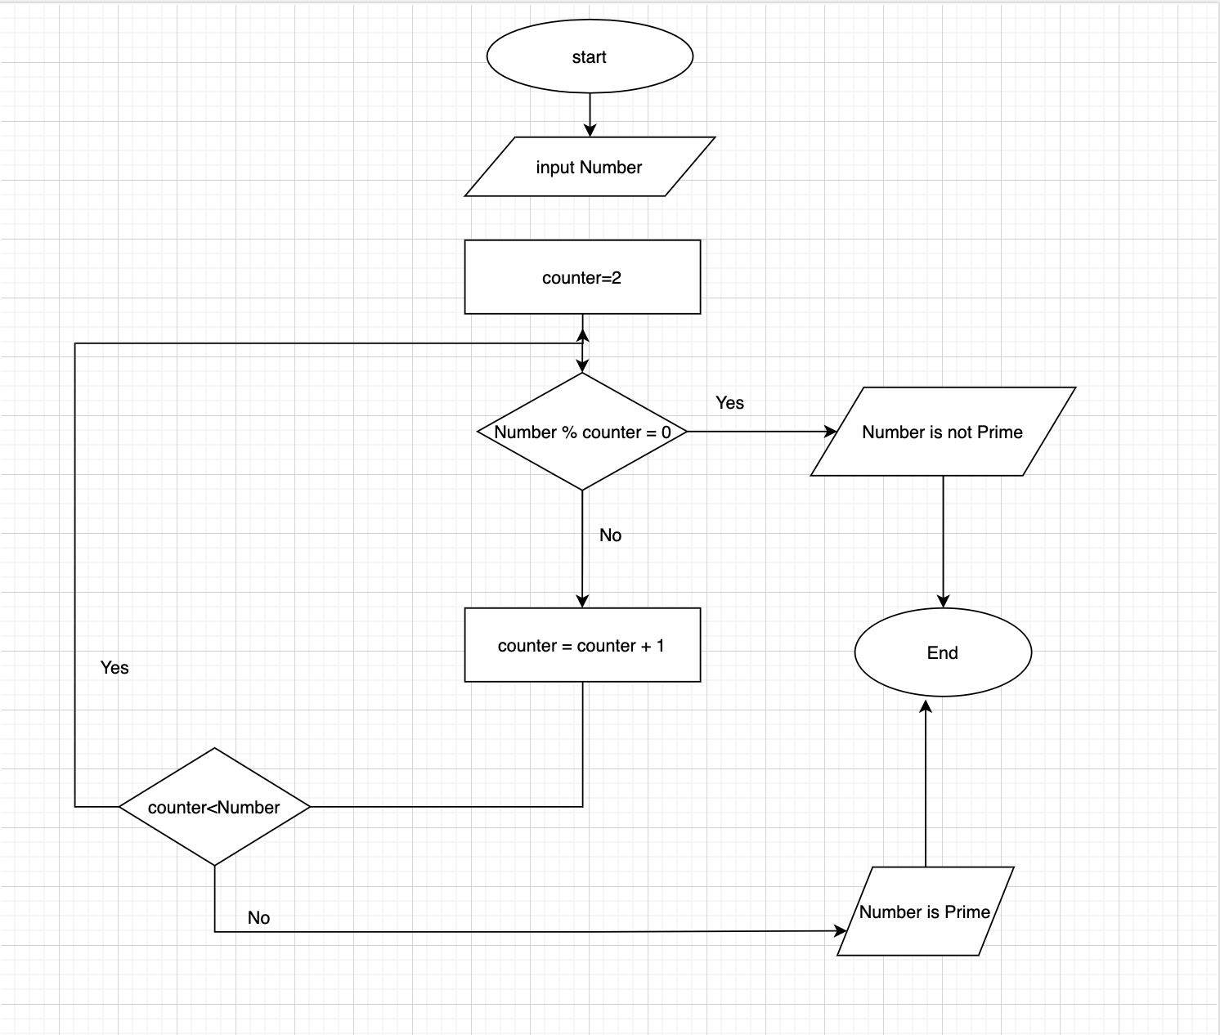

# Problem3

* Design an algorithm and a flowchart which receives a number from input and print the sum of the number’s digits. For instance if the number is 123 the algorithm return 6 which is the result of 1+2+3.

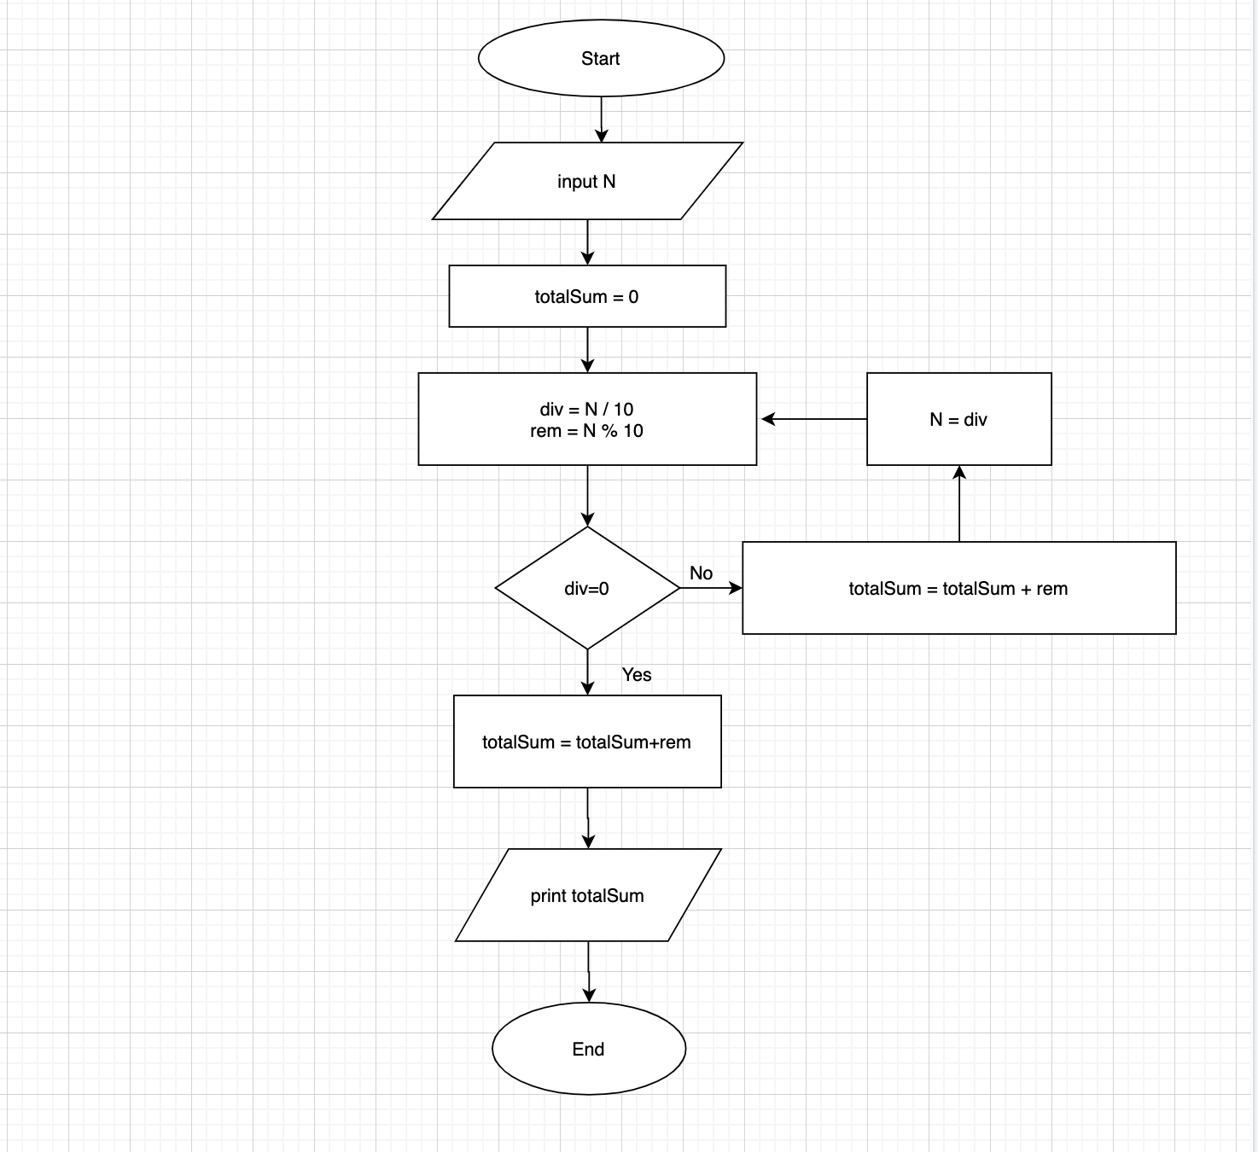

# Problem4

* Design an algorithm and a flowchart, which takes two integer numbers and swaps their values.

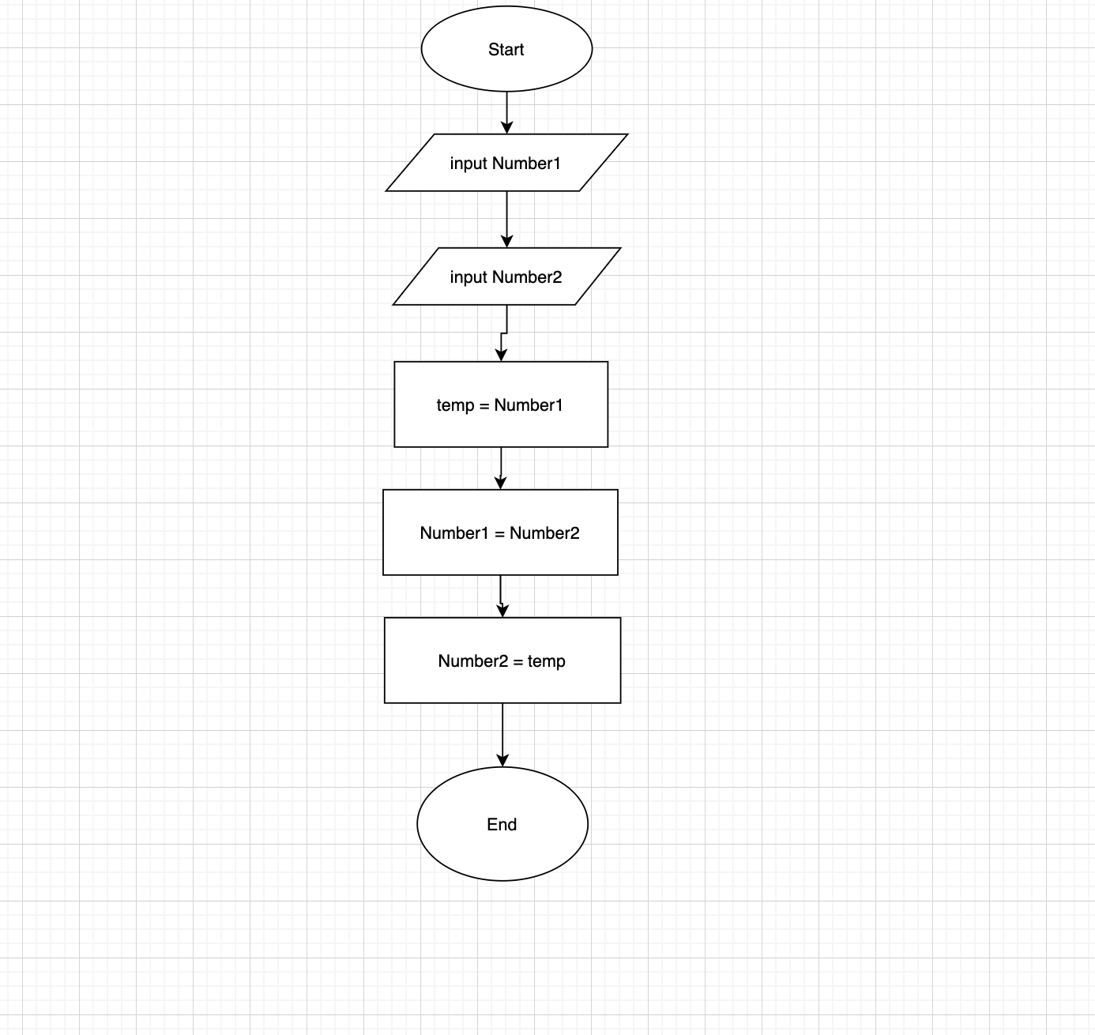

# Problem5

* Design an algorithm and a flowchart which receives two numbers A and B from the input and calculate the quotient without using the division (/) operator.
* Look at here to learn more: <https://en.wikipedia.org/wiki/Quotient>
* A = 18
* B = 4
* A / B = 4 (quotient)

